* Copyright for test papers and marking guides remains with *West Australian Test Papers*.
* The papers may only be reproduced within the purchasing school according to the advertised conditions of sale.
* Test papers must be withdrawn after use and stored securely in the school until Friday 12th June, 2020.

**HUMAN BIOLOGY**

**Unit 1**

**2020**



Name: _______________________________________________________

Teacher: ___________________________________________________

**Time allowed for this paper**

Reading time before commencing work: ten minutes

Working time: three hours

**Materials required/recommended for this paper**

***To be provided by the supervisor:***

This Question/Answer booklet

Multiple-choice answer sheet

***To be provided by the candidate:***

Standard items: pens (blue/black preferred), pencils (including coloured), sharpener, correction fluid/tape, eraser, ruler, highlighters

Special items: non-programmable calculators approved for use in this examination

**Important note to candidates**

No other items may be taken into the examination room. It is **your** responsibility to ensure that you do not have any unauthorised material. If you have any unauthorised material with you, hand it to the supervisor **before** reading any further.

**Structure of this paper**

|  |  |  |  |  |  |
| --- | --- | --- | --- | --- | --- |
| Section | Number of questions available | Number of questions to be attempted | Suggested working time (minutes) | Marks available | Percentage of examination |
| Section One  Multiple-choice | 30 | 30 | 40 | 30 | 30 |
| Section Two  Short answer | 7 | 7 | 90 | 106 | 50 |
| Section Three  Extended answer  Part 1  Part 2 | 2 | 1 | 50 | 40 | 20 |
| 2 | 1 |
|  |  |  |  | **Total** | 100 |

**Instructions to candidates**

1. The rules for the conduct of the Western Australian external examinations are detailed in the *Year 12 Information Handbook 2020*. Sitting this examination implies that you agree to abide by these rules.

2. Write your answers in this Question/Answer booklet preferably using a blue/black pen. Do not use erasable or gel pens.

3. Answer the questions according to the following instructions.

Section One: Answer all questions on the separate Multiple-choice answer sheet provided. For each question, shade the box to indicate your answer. Use only a blue or black pen to shade the boxes. Do not use erasable or gel pens. If you make a mistake, place a cross through that square, then shade your new answer. Do not erase or use correction fluid/tape. Marks will not be deducted for incorrect answers. No marks will be given if more than one answer is completed for any question.

Section Two: Write your answers in this Question/Answer booklet. Wherever possible, confine your answers to the line spaces provided.

Section Three: Consists of two parts each with two questions. You must answer one question from each part. Tick the box next to the question you are answering. Write your answers in this Question/Answer booklet.

4. You must be careful to confine your answers to the specific questions asked and to follow any instructions that are specific to a particular question.

5. Supplementary pages for planning/continuing your answers to questions are provided at the end of this Question/Answer booklet. If you use these pages to continue an answer, indicate at the original answer where the answer is continued, i.e. give the page number.

**Section One: Multiple-choice 30% (30 Marks)**

This section has **30** questions. Answer **all** questions on the separate Multiple-choice answer sheet provided. For each question shade the box to indicate your answer. Use only a blue or black pen to shade the boxes. Do not use erasable or gel pens. If you make a mistake, place a cross through that square, then shade your new answer. Do not erase or use correction fluid/tape. Marks will not be deducted for incorrect answers. No marks will be given if more than one answer is completed for any question.

Suggested working time: 40 minutes.

1. A scientist was measuring the weights of 100 athletes; however, the scale she used was measuring one kilogram higher than the true value. This is an example of
   1. user error.
   2. human error.
   3. random error.
   4. systematic error.
2. If a measuring cylinder reading is said to be 33.45 ± 0.05 cm3, which of the following values is **not** possible for the given reading?
   1. 33.39 cm3
   2. 33.50 cm3
   3. 33.47 cm3
   4. 33.42 cm3
3. Pancreatic cells produce and release lipase. Which of the following adaptations would you expect to find in these cells?
   1. Mitochondria with small internal membranes
   2. Large numbers of ribosomes
   3. A small surface area to volume ratio
   4. Cilia and flagella to allow for movement
4. Which of the following is the actual length of a cell that is 1 cm in length at a magnification of 100X?
   1. 0.01 mm
   2. 0.1 mm
   3. 1 mm
   4. 10 mm

Question 5 refers to the diagram below of the fluid compartments in the human body.

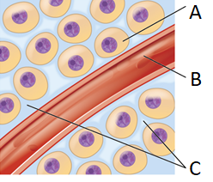

1. The fluid compartment represented by the letter A is referred to as
   1. lymph.
   2. intracellular fluid.
   3. interstitial fluid.
   4. extracellular fluid.
2. Which of the following correctly states the organic compound that, when aerobically catabolised, produces the most ATP?
   1. Protein
   2. Lipid
   3. Carbohydrate
   4. Deoxyribose nucleic acid (DNA)
3. Gastroesophageal reflux disease (GERD) is a condition that results in the liquid contents of the stomach to enter the oesophagus. The regurgitated liquid can cause damage to the oesophagus due to
   1. pepsin and amylase.
   2. nucleases and saliva.
   3. hydrochloric acid and pepsin.
   4. bile acids and proteases.
4. In which two body organs does the absorption of water take place?
   1. Kidneys and liver
   2. Large intestine and kidneys
   3. Liver and nephrons
   4. Kidneys and small intestine
5. Osteoporosis is associated with a loss of bone density. Which of the following bone cells would have excessive activity in a patient with this disease?
   1. Osteoclasts
   2. Osteoblasts
   3. Osteocytes
   4. Osteocrypts
6. A patient is diagnosed with cholecystitis, obstructing bile salt passage into the small intestine. As a result, the patient is unable to eat too much fat at one sitting. Which of the following organs does cholecystitis affect?
   1. Pancreas
   2. Liver
   3. Gall bladder
   4. Appendix
7. Ossification, or osteogenesis, is the process of creating new bone. This reaction is an example of
   1. catabolism.
   2. anabolism.
   3. metabolism.
   4. respiration.
8. Which of the following statements regarding the kidney is **correct**?
   1. The glomerulus along with the Bowman’s capsule is known as the renal corpuscle
   2. The section of the kidney known as the medulla consists of separate renal pelvis’
   3. The renal pyramid collects the filtrate to transport to the ureters
   4. The section of the nephron, known as the Loop of Henle, is found within the renal cortex
9. In which section of mitochondria does the Krebs (Citric Acid) cycle take place?
   1. Cristae
   2. Outer membrane
   3. Matrix
   4. Inner membrane
10. Which of the following groups correctly lists molecules which undergo facilitated diffusion?
    1. Water, oxygen and glucose
    2. Amino acids, glucose and sodium ions
    3. Glucose, fatty acids and oxygen
    4. Sodium ions, amino acids and carbon dioxide
11. The skeletal system has several functions. During a rugby tackle, which of the following functions would be **most** important?
    1. Storage
    2. Movement
    3. Support
    4. Protection
12. A Year 11 student suffered a broken leg after a skateboarding accident, with the X-ray showing the fracture in the shaft of the bone. What is the anatomical name given to this part of the bone?
    1. Epiphysis
    2. Diaphysis
    3. Metaphysis
    4. Periosteum
13. Elimination differs from excretion in that elimination
    1. includes undigested materials as well as metabolic wastes.
    2. only consists of metabolic wastes.
    3. only consists of undigested materials.
    4. includes digested and undigested materials.
14. The lymphatic capillary found in the small intestine that absorbs dietary fats is known as the
    1. duodenum.
    2. lacteal.
    3. villi.
    4. intestinal gland.

Question 19 refers to the table below.

Table 1. Weight of two babies at monthly intervals in their first 6 months after birth

|  |  |  |
| --- | --- | --- |
|  | Weight (kg) | |
| Month | Baby #1 | Baby #2 |
| 0 | 3.2 | 2.7 |
| 1 | 4.1 | 2.9 |
| 2 | 5.4 | 3.4 |
| 3 | 5.8 | 3.9 |
| 4 | 6.2 | 4.6 |
| 5 | 6.6 | 5.5 |
| 6 | 7.2 | 6.4 |

1. Which of the following graphs is the most appropriate way to represent the data in the table above?
   1. Histogram
   2. Bar graph
   3. Line graph
   4. Pie chart
2. Humans require nutrients for biochemical processes to occur efficiently. Which of the following is **not** a metabolic reason as to why the body is made up mostly of water?

Water acts as a

* 1. reactant in metabolic reactions.
  2. universal solvent.
  3. medium for metabolic reactions.
  4. transport medium.

1. A defibrillator uses a high energy electric shock to the heart to restart it beating. Which type of tissue does the defibrillator act on?
   1. Connective
   2. Epithelial
   3. Muscle
   4. Nervous

Question 22 refers to the short axis (horizontal cut) section diagram of the anterior view of the heart below.

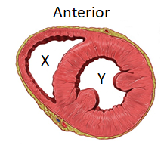

1. The section of the heart labelled as Y is the
   1. right ventricle.
   2. left ventricle.
   3. right atrium.
   4. left atrium.

Question 23 refers to the information about age and bone mass below.

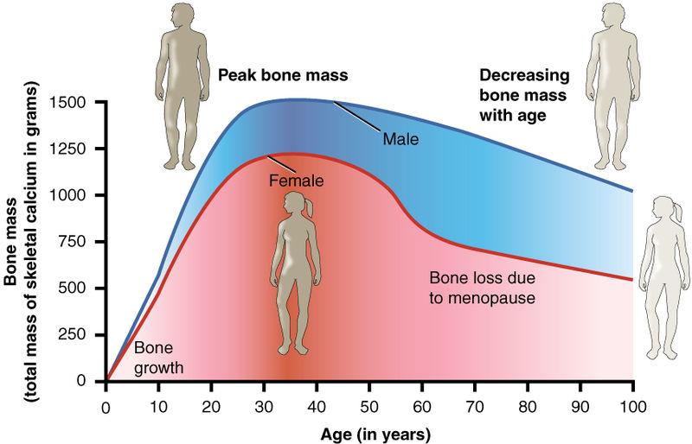

1. The average yearly rate of bone loss in women between the ages of 60 and 100 is
   1. 5.
   2. 5.5.
   3. 6.25.
   4. 6.75.

Question 24 and 25 refer to the diagram of the skeletal muscle below.

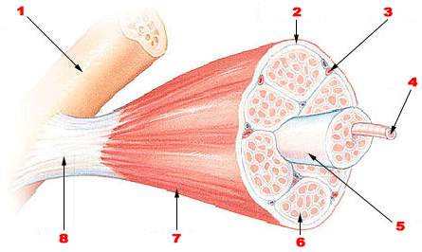

1. The section of the muscle identified at number 4 is known as a
   1. myofibril.
   2. myofilament.
   3. sarcomere.
   4. muscle fibre.
2. Damage to the structure identified at number 8 would result in
   1. muscle spasms, causing repetitive contraction and relaxation of the joint.
   2. inability to move the affected arm or leg.
   3. decreased transportation of nutrients between muscle and bone.
   4. less protection of the adjacent muscle causing more damage to the structure.
3. Which of the following correctly lists the form and location that nutrients are absorbed in the digestive system?

|  |  |  |
| --- | --- | --- |
| (a) | Proteins | Blood capillary in small intestine |
| (b) | Glycerol | Lymph capillaries in the large intestine |
| (c) | Sucrose | Blood capillaries in the small intestine |
| (d) | Amino acids | Blood capillaries in the stomach |

1. In which part of the digestive tract are Goblet cells, which secrete mucus, most common?
   1. Oesophagus
   2. Small intestine
   3. Stomach
   4. Large intestine
2. Ethanol can directly cross the cell membrane because it is a
   1. hydrophobic molecule.
   2. small uncharged polar molecule.
   3. large uncharged polar molecule.
   4. charged ion.
3. Energy in human cells is stored as
   1. glycogen.
   2. glucose.
   3. ADP.
   4. ATP.
4. If the epithelial cells of the respiratory system are damaged, which of the following will **not** occur?
   1. Filtration of particles of dirt and debris
   2. Reduced exchange of carbon dioxide and oxygen
   3. Temperature of the air will remain too high or too low
   4. Reduced movement of lungs during inhalation

**End of Section One**

**This page has been left blank intentionally**

**Section Two: Short answer 50% (106 Marks)**

This section has **seven** questions. Answer **all** questions. Write your answers in the spaces provided.

Supplementary pages for planning/continuing your answers to questions are provided at the end of this Question/Answer booklet. If you use these pages to continue an answer, indicate at the original answer where the answer is continued, i.e. give the page number.

Suggested working time: 90 minutes.

**Question 31 (14 marks)**

The diagram below shows a model cell used by a student to investigate osmosis.

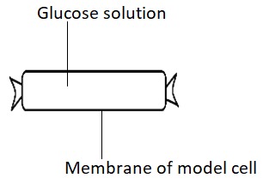

1. State a material that can be used as the membrane of the model cell and describe the feature that makes it suitable to use in this experiment. (2 marks)

___________________________________________________________________

___________________________________________________________________

___________________________________________________________________

Four model cells, labelled A, B, C and D, were constructed and contained 0%, 5%, 10% and 20% glucose solutions respectively. The model cells were weighed then suspended in four test tubes containing a 10% glucose solution. One hour later the model cells were removed and reweighed.

1. In the space below, draw a labelled diagram of the experimental set up.

(4 marks)

1. Predict which model, A, B, C or D, would have the greatest change in mass after the given hour. Give a detailed explanation for your answer. (5 marks)

___________________________________________________________________

___________________________________________________________________

___________________________________________________________________

___________________________________________________________________

___________________________________________________________________

___________________________________________________________________

___________________________________________________________________

___________________________________________________________________

___________________________________________________________________

___________________________________________________________________

___________________________________________________________________

1. What is the name given to the type of solution in the test tube of Model C?

(1 mark)

___________________________________________________________________

1. The student repeated the experiment three times. Describe why scientists undertake multiple tests and calculate mean results. (2 marks)

___________________________________________________________________

___________________________________________________________________

___________________________________________________________________

___________________________________________________________________

**Question 32 (16 marks)**

Jasmine was interested in learning more about the digestive system. She took a bite of white bread and left it in her mouth for a long period of time. After it became mushy, it started to taste sweet.

1. Explain why bread becomes mushy and starts to taste sweet when left in the mouth for an extended period. (5 marks)

___________________________________________________________________

___________________________________________________________________

___________________________________________________________________

___________________________________________________________________

___________________________________________________________________

___________________________________________________________________

___________________________________________________________________

___________________________________________________________________

___________________________________________________________________

___________________________________________________________________

Once swallowed, the bolus of bread passes through the oesophagus, into the stomach and then the intestines where it is further broken down.

1. Describe the mechanical digestion which occurs in the stomach. (4 marks)

___________________________________________________________________

___________________________________________________________________

___________________________________________________________________

___________________________________________________________________

___________________________________________________________________

___________________________________________________________________

___________________________________________________________________

___________________________________________________________________

Jasmine had recently been sick due to food poisoning. The bacteria, E. coli, attaches to the columnar epithelia of the small intestine.

1. Describe why Jasmine’s doctor is concerned about her nutrient absorption. (3 marks)

___________________________________________________________________

___________________________________________________________________

___________________________________________________________________

___________________________________________________________________

___________________________________________________________________

___________________________________________________________________

1. State two nutritional differences between a non-vegetarian and vegetarian diet and give an example of the effects these can have on the body. (4 marks)

___________________________________________________________________

___________________________________________________________________

___________________________________________________________________

___________________________________________________________________

___________________________________________________________________

___________________________________________________________________

___________________________________________________________________

___________________________________________________________________

**Question 33 (13 marks)**

A Blood Urea Nitrogen (BUN) test is a common diagnostic tool for investigations into kidney function.

1. Explain how urea is formed. (4 marks)

___________________________________________________________________

___________________________________________________________________

___________________________________________________________________

___________________________________________________________________

___________________________________________________________________

___________________________________________________________________

___________________________________________________________________

___________________________________________________________________

Increased BUN levels can be due to prerenal, renal and postrenal factors.

1. Describe how decreased blood flow through the kidneys can result in excess urea in the blood. (3 marks)

___________________________________________________________________

___________________________________________________________________

___________________________________________________________________

___________________________________________________________________

___________________________________________________________________

___________________________________________________________________

1. On the diagram below, label an arrow to identify **one** location where urea is reabsorbed and **one** location where it is secreted. (3 marks)

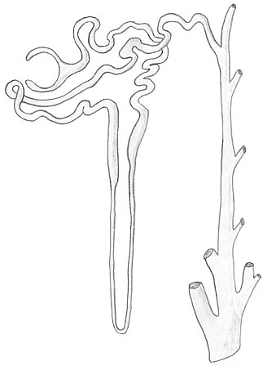

Patients with kidney failure can be treated with dialysis; however, kidney transplants are more efficient.

1. Suggest **two** reasons against the use of kidney transplants. (2 marks)

___________________________________________________________________

___________________________________________________________________

___________________________________________________________________

___________________________________________________________________

1. Outline why lungs are also considered to be an excretory organ. (1 mark)

___________________________________________________________________

___________________________________________________________________

**Question 34 (19 marks)**

The Health Department of WA runs several initiatives to help increase the community’s physical activity levels. One type of exercise that is often undertaken is weightlifting.

1. State **one** benefit of weightlifting on the body. (1 mark)

___________________________________________________________________

1. During weightlifting sessions, people often feel a burning sensation in the muscle group they are working. Explain why this occurs. (5 marks)

___________________________________________________________________

___________________________________________________________________

___________________________________________________________________

___________________________________________________________________

___________________________________________________________________

___________________________________________________________________

___________________________________________________________________

___________________________________________________________________

The Health Department of WA also hosts a list of all the sport events occurring in the state. Fun runs are a common event on this list, and it is common to find competitors “carb loading” the night before a race.

1. Explain why endurance athletes load up on carbohydrates prior to running marathons. (4 marks)

___________________________________________________________________

___________________________________________________________________

___________________________________________________________________

___________________________________________________________________

___________________________________________________________________

___________________________________________________________________

___________________________________________________________________

1. Describe why there is an increase in blood flow to the lungs during exercise.

(3 marks)

___________________________________________________________________

___________________________________________________________________

___________________________________________________________________

___________________________________________________________________

___________________________________________________________________

___________________________________________________________________

Poor breathing technique during exercise can result in fatigue and dizziness.

1. Explain why paradoxical breathing, when your stomach rises on exhale and sinks on inhale, is inefficient. (6 marks)

___________________________________________________________________

___________________________________________________________________

___________________________________________________________________

___________________________________________________________________

___________________________________________________________________

___________________________________________________________________

___________________________________________________________________

___________________________________________________________________

___________________________________________________________________

___________________________________________________________________

___________________________________________________________________

___________________________________________________________________

**Question 35 (15 marks)**

The diagram below illustrates a simplified version of an animal cell.

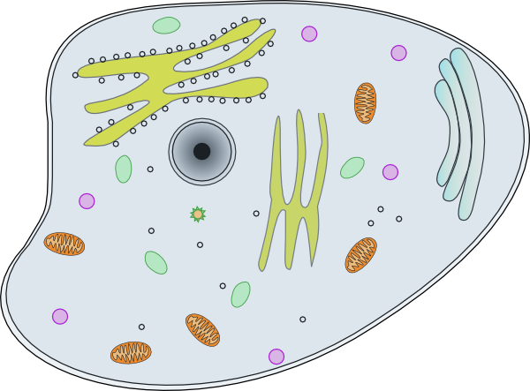

**C**

**F**

**E**

**B**

**As**

**D**

1. Identify the following organelles from the diagram above: (2 marks)

C: ___________________________________________

D: ___________________________________________

1. Describe how Organelles A and E differ in structure and function. (2 marks)

___________________________________________________________________

___________________________________________________________________

___________________________________________________________________

___________________________________________________________________

1. Organelle F entered the cell via a process known as endocytosis. Describe this process. (5 marks)

___________________________________________________________________

___________________________________________________________________

___________________________________________________________________

___________________________________________________________________

___________________________________________________________________

___________________________________________________________________

1. Describe how the structure of the cell membrane allows for transport of materials via exocytosis. (2 marks)

___________________________________________________________________

___________________________________________________________________

___________________________________________________________________

___________________________________________________________________

Erythrocytes (red blood cells) are of equal size in both humans and mice, although their body size differs considerably.

1. Explain why the size of an erythrocyte is the same in these two species. (4 marks)

___________________________________________________________________

___________________________________________________________________

___________________________________________________________________

___________________________________________________________________

___________________________________________________________________

___________________________________________________________________

___________________________________________________________________

___________________________________________________________________

**Question 36 (17 marks)**

Rigor mortis is the rigidity of the body after death, characterised by stiffening of the limbs. Chemical changes in the muscles cause a continual flood of calcium ions into the contractile units of the muscle fibres.

1. State the name given to the contractile unit of a muscle fibre. (1 mark)

___________________________________________________________________

1. Explain why the influx of calcium ions causes rigor mortis to occur. (6 marks)

___________________________________________________________________

___________________________________________________________________

___________________________________________________________________

___________________________________________________________________

___________________________________________________________________

___________________________________________________________________

___________________________________________________________________

___________________________________________________________________

___________________________________________________________________

The contraction of skeletal muscles on joints results in movement of the body, such as arms and legs.

1. Describe how the actions of muscles result in movement and provide a specific example to demonstrate your answer. (5 marks)

___________________________________________________________________

___________________________________________________________________

___________________________________________________________________

______________________________________________________________________________________________________________________________________

___________________________________________________________________

___________________________________________________________________

During physical activity, heart rate increases. Although a single organ, the heart functions as a double pump.

1. Describe how the circulatory system distributes blood around the body.

(5 marks)

___________________________________________________________________

___________________________________________________________________

___________________________________________________________________

___________________________________________________________________

___________________________________________________________________

___________________________________________________________________

___________________________________________________________________

___________________________________________________________________

___________________________________________________________________

___________________________________________________________________

**Question 37 (12 marks)**

The figures below show the histological picture of the three different types of cartilage and their components.

**X Y Z**

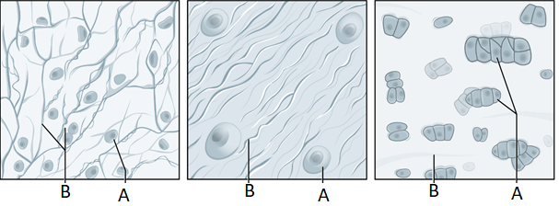

1. Identify the type of cartilage represented by figure X and justify your reason.

(2 marks)

___________________________________________________________________

___________________________________________________________________

___________________________________________________________________

___________________________________________________________________

1. State **one** location where the cartilage represented by figure Z would be found.

(1 mark)

___________________________________________________________________

Ossification is the conversion of cartilage to bone.

1. Identify **two** aspects of bone that are not found in cartilage. (2 marks)

___________________________________________________________________

___________________________________________________________________

___________________________________________________________________

The diagram below is a cross section of bone.

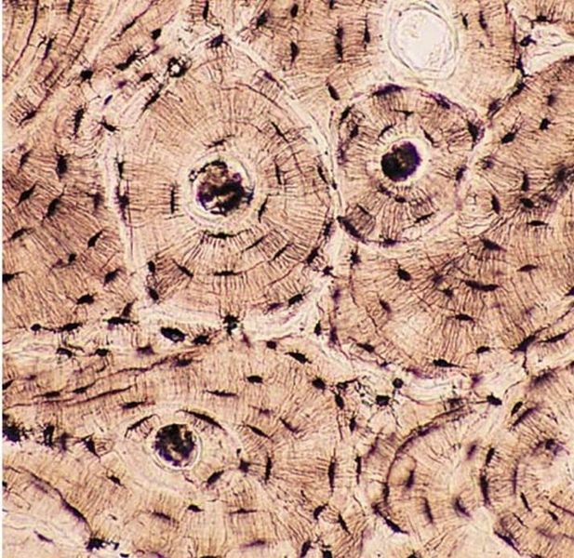

1. (i) Identify the type of bone that this sample would have been taken from.

(1 mark)

_______________________________________________________

1. State the name given to the functional unit of this bone. (1 mark)

_______________________________________________________

Joints are found where two or more bones meet and are often associated with movement.

1. Describe how age and ongoing damage to a joint can result in restricted movement. (5 marks)

___________________________________________________________________

___________________________________________________________________

___________________________________________________________________

___________________________________________________________________

___________________________________________________________________

___________________________________________________________________

___________________________________________________________________

___________________________________________________________________

___________________________________________________________________

___________________________________________________________________

**End of Section Two**

**Section Three: Extended answer 20% (40 Marks)**

Section Three consists of **four** questions.

Questions 38 and 39 are from Part 1. Question 40 and 41 are from Part 2. Answer **one** question from Part 1 and **one** question from Part 2.

Use black or blue pen for this section. Only graphs and diagrams may be drawn in pencil. Responses can include: labelled diagrams with explanatory notes; lists of points with linking sentences; labelled tables and/or graphs; and/or annotated flow diagrams with introductory notes.

Supplementary pages for planning/continuing your answers to questions are provided at the end of this Question/Answer booklet. If you use these pages to continue an answer, indicate at the original answer where the answer is continued, i.e. give the page number.

Suggested working time: 50 minutes.

**Part 1**

Choose **either** Question 38 **or** Question 39.

Indicate the question you will answer by ticking the box next to the question. Write your answer on pages 28 - 32. When you have answered your first question, turn to page 33 and indicate on that page the second question you will answer.

**Question 38 (20 marks)**

The requirements of cells differ both between cell types and over time. Biochemical processes occurring in the cell during these times are controlled by the presence of enzymes.

1. Briefly describe the role of an enzyme and explain how an enzyme’s function can be altered due to the presence of other molecules. (12 marks)

The nutritional requirements for cells are obtained through the digestive system. The supply of these nutrients is facilitated by enzymes produced in specialised cells and released into the digestive organs.

1. State the specialised cell which produces gastric enzymes and describe the role of the gastric enzymes to supply soluble nutrients. (8 marks)

**Question 39 (20 marks)**

The human body is composed of tissues, which are groups of cells that perform specific functions.

1. Identify and compare the types of tissues that make up the muscular system.

(8 marks)

1. Describe the lymphatic system and explain how it works in conjunction with the circulatory system, describing what would occur if the lymphatic system became blocked in the lower leg of a patient. (12 marks)

Question number: _______________

_________________________________________________________________________

__________________________________________________________________________________________________________________________________________________

__________________________________________________________________________________________________________________________________________________

__________________________________________________________________________________________________________________________________________________

__________________________________________________________________________________________________________________________________________________

__________________________________________________________________________________________________________________________________________________

__________________________________________________________________________________________________________________________________________________

__________________________________________________________________________________________________________________________________________________

__________________________________________________________________________________________________________________________________________________

__________________________________________________________________________________________________________________________________________________

__________________________________________________________________________________________________________________________________________________

__________________________________________________________________________________________________________________________________________________

__________________________________________________________________________________________________________________________________________________

__________________________________________________________________________________________________________________________________________________

Question number: _______________

__________________________________________________________________________________________________________________________________________________

__________________________________________________________________________________________________________________________________________________

__________________________________________________________________________________________________________________________________________________

__________________________________________________________________________________________________________________________________________________

__________________________________________________________________________________________________________________________________________________

__________________________________________________________________________________________________________________________________________________

___________________________________________________________________________________________________________________________________________________________________________________________________________________________

__________________________________________________________________________________________________________________________________________________

__________________________________________________________________________________________________________________________________________________

__________________________________________________________________________________________________________________________________________________

__________________________________________________________________________________________________________________________________________________

__________________________________________________________________________________________________________________________________________________

__________________________________________________________________________________________________________________________________________________

Question number: _______________

__________________________________________________________________________________________________________________________________________________

__________________________________________________________________________________________________________________________________________________

__________________________________________________________________________________________________________________________________________________

__________________________________________________________________________________________________________________________________________________

__________________________________________________________________________________________________________________________________________________

__________________________________________________________________________________________________________________________________________________

__________________________________________________________________________________________________________________________________________________

__________________________________________________________________________________________________________________________________________________

__________________________________________________________________________________________________________________________________________________

__________________________________________________________________________________________________________________________________________________

__________________________________________________________________________________________________________________________________________________

__________________________________________________________________________________________________________________________________________________

__________________________________________________________________________________________________________________________________________________

_________________________________________________________________________

Question number: _______________

__________________________________________________________________________________________________________________________________________________

__________________________________________________________________________________________________________________________________________________

__________________________________________________________________________________________________________________________________________________

__________________________________________________________________________________________________________________________________________________

__________________________________________________________________________________________________________________________________________________

__________________________________________________________________________________________________________________________________________________

__________________________________________________________________________________________________________________________________________________

__________________________________________________________________________________________________________________________________________________

__________________________________________________________________________________________________________________________________________________

__________________________________________________________________________________________________________________________________________________

__________________________________________________________________________________________________________________________________________________

__________________________________________________________________________________________________________________________________________________

__________________________________________________________________________________________________________________________________________________

_________________________________________________________________________

Question number: _______________

__________________________________________________________________________________________________________________________________________________

__________________________________________________________________________________________________________________________________________________

__________________________________________________________________________________________________________________________________________________

__________________________________________________________________________________________________________________________________________________

__________________________________________________________________________________________________________________________________________________

__________________________________________________________________________________________________________________________________________________

__________________________________________________________________________________________________________________________________________________

__________________________________________________________________________________________________________________________________________________

__________________________________________________________________________________________________________________________________________________

__________________________________________________________________________________________________________________________________________________

__________________________________________________________________________________________________________________________________________________

__________________________________________________________________________________________________________________________________________________

__________________________________________________________________________________________________________________________________________________

_________________________________________________________________________

**Part 2**

Choose **either** Question 40 **or** Question 41.

Indicate the question you will answer by ticking the box next to the question. Write your answer on the pages provided.

**Question 40 (20 marks)**

Active processes are involved in the formation of urine as it passes through the nephron allowing the body to regulate chemical composition of body fluids.

1. State what substances are actively removed and added to the filtrate, giving reason for their movement. (8 marks)

Joints are constructed to allow for differing types and degrees of movement.

1. Discuss the similarities between the knee and hip joints and identify how the structure of these two joints allows for the variation in movement seen at the joints.

(12 marks)

**Question 41 (20 marks)**

1. Explain how oxygen is exchanged in the lungs and transported throughout the body. (10 marks)

ABO blood groups were discovered over 100 years ago. Prior to this, all blood was thought to be the same and the outcomes of blood transfusions were often tragic. ABO typing is now used to determine a person’s blood group prior to surgeries that may require blood transfusions.

1. Describe how blood groups are determined and explain the importance of having this completed prior to a blood transfusion. (10 marks)

**End of Questions**

Question number: _______________

_________________________________________________________________________

__________________________________________________________________________________________________________________________________________________

__________________________________________________________________________________________________________________________________________________

__________________________________________________________________________________________________________________________________________________

__________________________________________________________________________________________________________________________________________________

__________________________________________________________________________________________________________________________________________________

__________________________________________________________________________________________________________________________________________________

__________________________________________________________________________________________________________________________________________________

__________________________________________________________________________________________________________________________________________________

__________________________________________________________________________________________________________________________________________________

__________________________________________________________________________________________________________________________________________________

__________________________________________________________________________________________________________________________________________________

__________________________________________________________________________________________________________________________________________________

__________________________________________________________________________________________________________________________________________________

Question number: _______________

__________________________________________________________________________________________________________________________________________________

__________________________________________________________________________________________________________________________________________________

__________________________________________________________________________________________________________________________________________________

__________________________________________________________________________________________________________________________________________________

__________________________________________________________________________________________________________________________________________________

__________________________________________________________________________________________________________________________________________________

___________________________________________________________________________________________________________________________________________________________________________________________________________________________

__________________________________________________________________________________________________________________________________________________

__________________________________________________________________________________________________________________________________________________

__________________________________________________________________________________________________________________________________________________

__________________________________________________________________________________________________________________________________________________

__________________________________________________________________________________________________________________________________________________

__________________________________________________________________________________________________________________________________________________

Question number: _______________

__________________________________________________________________________________________________________________________________________________

__________________________________________________________________________________________________________________________________________________

__________________________________________________________________________________________________________________________________________________

__________________________________________________________________________________________________________________________________________________

__________________________________________________________________________________________________________________________________________________

__________________________________________________________________________________________________________________________________________________

__________________________________________________________________________________________________________________________________________________

__________________________________________________________________________________________________________________________________________________

__________________________________________________________________________________________________________________________________________________

__________________________________________________________________________________________________________________________________________________

__________________________________________________________________________________________________________________________________________________

__________________________________________________________________________________________________________________________________________________

__________________________________________________________________________________________________________________________________________________

_________________________________________________________________________

Question number: _______________

__________________________________________________________________________________________________________________________________________________

__________________________________________________________________________________________________________________________________________________

__________________________________________________________________________________________________________________________________________________

__________________________________________________________________________________________________________________________________________________

__________________________________________________________________________________________________________________________________________________

__________________________________________________________________________________________________________________________________________________

__________________________________________________________________________________________________________________________________________________

__________________________________________________________________________________________________________________________________________________

__________________________________________________________________________________________________________________________________________________

__________________________________________________________________________________________________________________________________________________

__________________________________________________________________________________________________________________________________________________

__________________________________________________________________________________________________________________________________________________

__________________________________________________________________________________________________________________________________________________

_________________________________________________________________________

Question number: _______________

__________________________________________________________________________________________________________________________________________________

__________________________________________________________________________________________________________________________________________________

__________________________________________________________________________________________________________________________________________________

__________________________________________________________________________________________________________________________________________________

__________________________________________________________________________________________________________________________________________________

__________________________________________________________________________________________________________________________________________________

__________________________________________________________________________________________________________________________________________________

__________________________________________________________________________________________________________________________________________________

__________________________________________________________________________________________________________________________________________________

__________________________________________________________________________________________________________________________________________________

__________________________________________________________________________________________________________________________________________________

__________________________________________________________________________________________________________________________________________________

__________________________________________________________________________________________________________________________________________________

_________________________________________________________________________

Supplementary page

Question number: _______________

__________________________________________________________________________________________________________________________________________________

__________________________________________________________________________________________________________________________________________________

__________________________________________________________________________________________________________________________________________________

__________________________________________________________________________________________________________________________________________________

__________________________________________________________________________________________________________________________________________________

__________________________________________________________________________________________________________________________________________________

__________________________________________________________________________________________________________________________________________________

__________________________________________________________________________________________________________________________________________________

__________________________________________________________________________________________________________________________________________________

__________________________________________________________________________________________________________________________________________________

__________________________________________________________________________________________________________________________________________________

__________________________________________________________________________________________________________________________________________________

________________________________________________________________________________________________________

**ACKNOWLEDGEMENTS**

**Question 5** BC Campus: Rice University. (N.D.). Anatomy and Physiology. Fluid Compartments in the Human Body [Image]. Retrieved 27th November, 2019, from:

<https://opentextbc.ca/anatomyandphysiology/chapter/26-1-body-fluids-and-fluid-compartments/>

**Question 22** Patrick J. Lynch. (2006). Heart normal short axis [Image]. Retrieved 28th October, 2019, from: <https://commons.wikimedia.org/wiki/File:Heart_normal_short_axis_section.jpg>

**Question 23** OpenStax College. (2013). Anatomy and Physiology, Connexions Website. *Age and Bone Mass* [Graph]. Retrieved 15th December, 2019, from:

<https://commons.wikimedia.org/wiki/File:615_Age_and_Bone_Mass.jpg>

**Question 24** Fran Rogers. (2007). Skeletal Muscle [Image]. Retrieved 28th October, 2019, from: <https://commons.wikimedia.org/wiki/File:Skeletal_muscle.png>

**Question 25** Fran Rogers. (2007). Skeletal Muscle [Image]. Retrieved 28th October, 2019, from: <https://commons.wikimedia.org/wiki/File:Skeletal_muscle.png>

**Question 33** CKRobinson. (2007). Unlabelled diagram of a mammalian nephron [Image]. Retrieved 2nd October, 2019, from: <https://commons.wikimedia.org/w/index.php?curid=45678885>

**Question 35** Shared by OCAL. (2010). Animal Cell Clip Art [Image]. Retrieved 16th October, 2019, from: <http://www.clker.com/clipart-animal-cell.html>

**Question 37** OpenStax College. (2013). Anatomy and Physiology, Connexions Website. *Types of Cartilage.* Retrieved 18th December, 2019, from: <https://commons.wikimedia.org/wiki/File:412_Types_of_Cartilage-new.jpg>

**Question 37** Darshani Kansara. (2014). Bone Connective Tissue [Image]. Retrieved 29th October, 2019, from:

<https://commons.wikimedia.org/wiki/File:Bone_connective_tissue.jpg>